Step 3. Ensure that students can display files from their Dropbox folder using URLs

* Log into PI and click on the orange XAMPP Control Panel Icon on the Taskbar

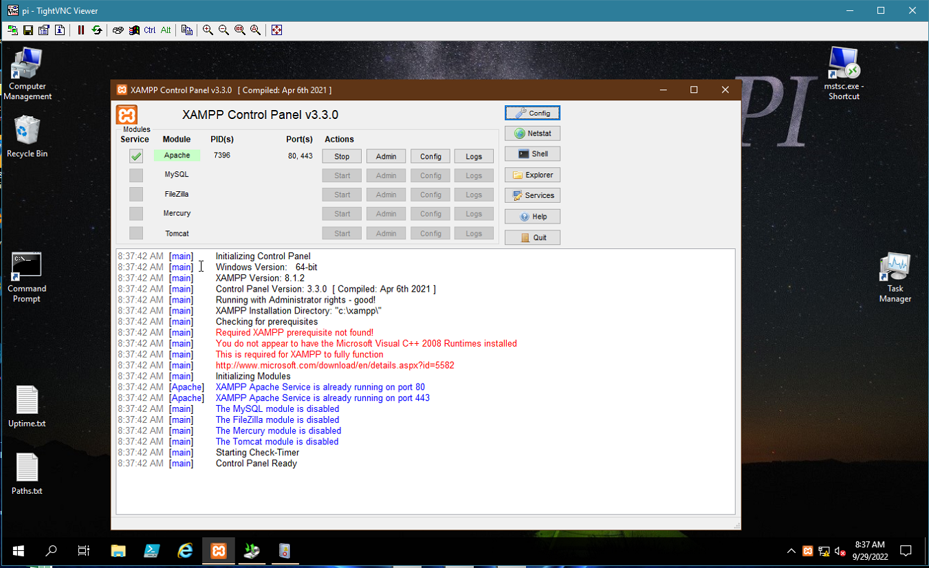

Click the Apache Config Button, and choose the first option (Apache (httpd.conf).

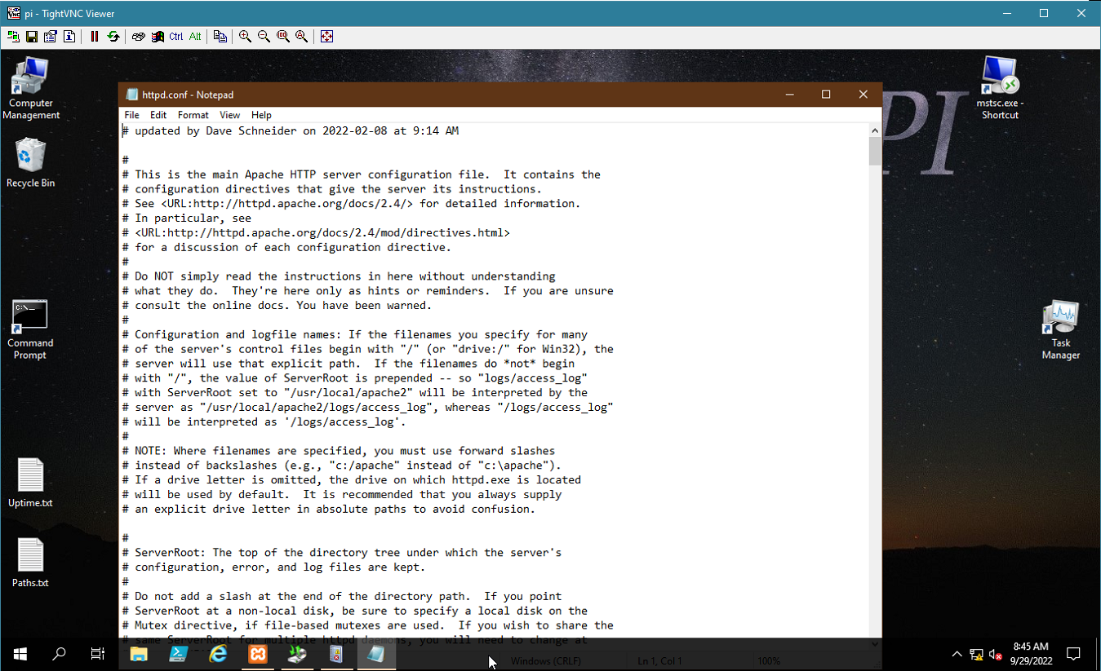

Here’s where you’ll be working.

Scroll down to where it says ‘add student directories here’ (and note the notes).

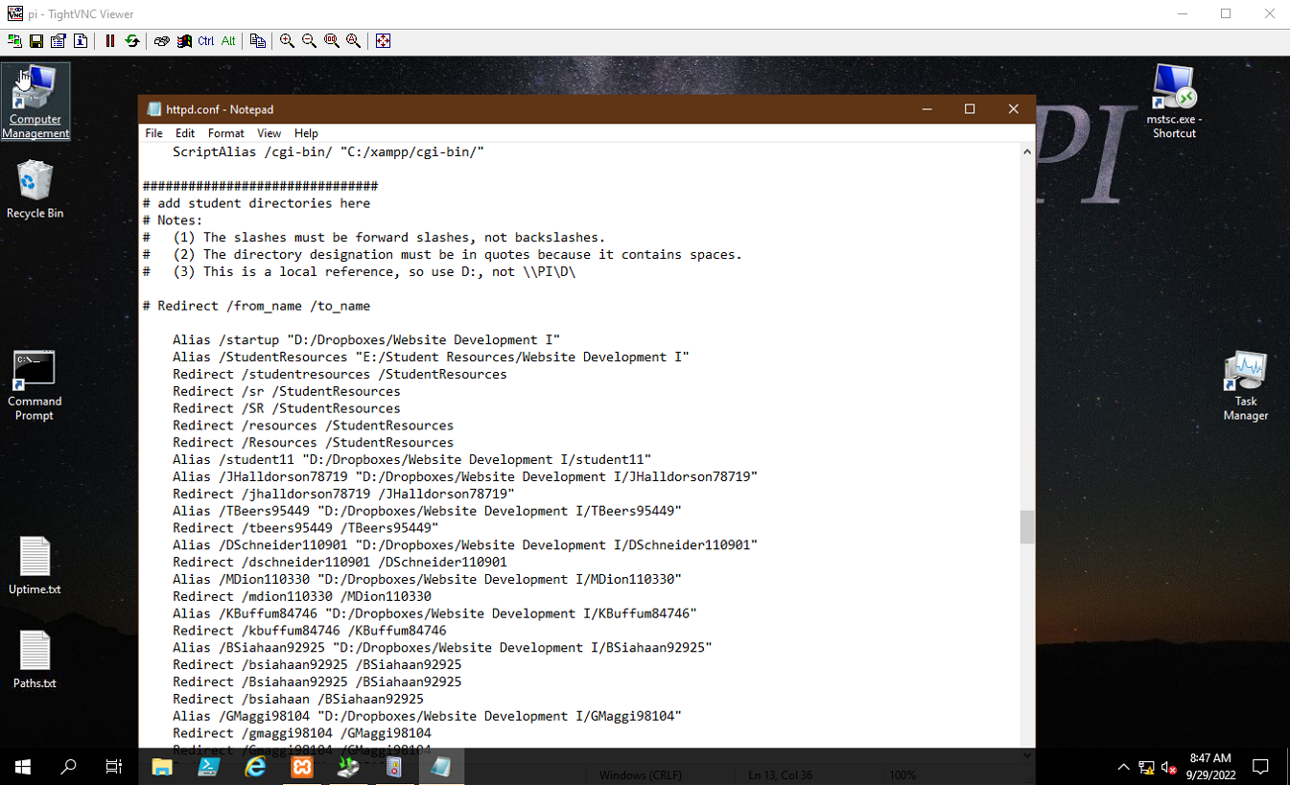

Scroll to the end of the student listings, add a comment line with the next class (just to show a little separation), and add the new students here, following the examples of the existing students.

!! CAPITALIZATION is critical and makes a difference !!

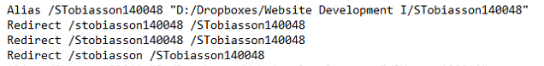

These must be unique

Notice that the first is all small letters, the second has one initial Cap, and the third has no Inmate ID. If you duplicate one or more, they won’t load, and you’ll get a redirect error or a network connection error in your browser.

When you’re done, save the text file (note that you’re just using notepad) the normal way.

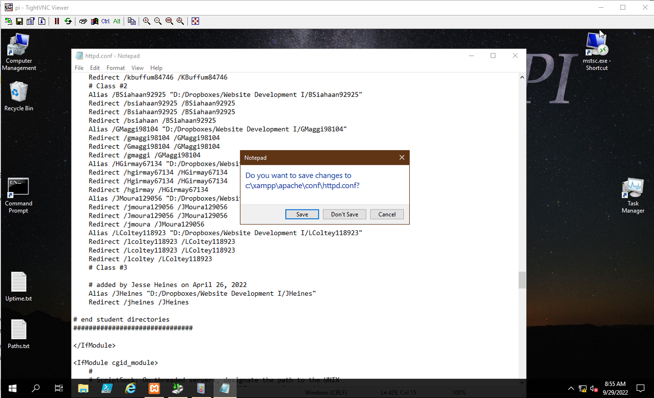

You must \*STOP\* and \*RESTART\* the Apache server for the changes to take place. After you click ‘Stop’, click the same button (which will read Start)

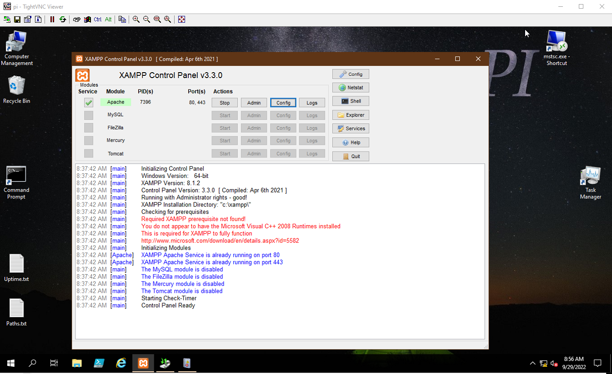

*This document was created by Mr. Schneider and given to me on October 6, 2022.*