**Progressive Music Examples**

prepared for a workshop at

**Scratch@MIT**

Friday, August 13, 2010

**S. Alex Ruthmann**

Prof. of Music Education

Alex_Ruthmann@uml.edu

**Jesse M. Heines**

Prof. of Computer Science

Jesse_Heines@uml.edu

**University of Massachusetts Lowell**

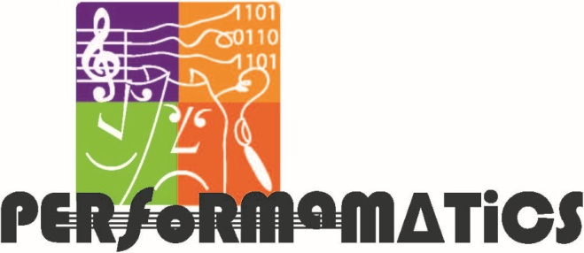 

**Program Source Locations**

**http://scratch.mit.edu/users/performamatics**

**Gallery: “Scratch@MIT, August 13, 2010”**

**http://scratch.mit.edu/galleries/view/90913**

**Table of Examples**

**No. 1: Playing Notes 5**

**No. 2: Playing Notes Using Variables 7**

**No. 3: Separating Initialization 9**

**No. 4: Separating Phrases 11**

**No. 5: Looping and Fading 15**

**No. 6: Playing a Round with One Instrument 17**

**No. 7: Playing a Round with Two Instruments 19**

**No. 8: Storing Notes and Rhythms in Lists 23**

**No. 9: Playing a Round Using Lists 25**

**No. 10: Synchronizing Play from Lists 27**

**Ideas for Extending the Examples 31**

**Important Note**

**The timing of virtually all music scripts can be improved by setting Turbo Speed. To do this, select:**

**Edit Set Single Stepping... Turbo Speed**

**Progressive Music Examples**

**No. 1: Playing Notes**

**Single Script**

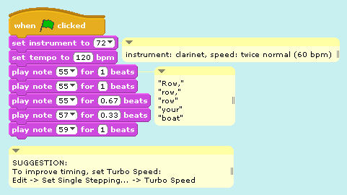

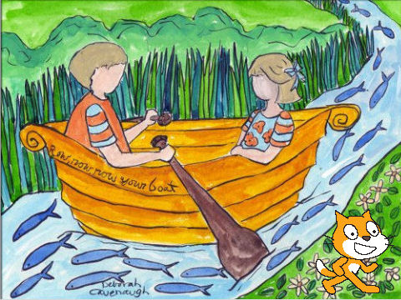 **Output  
 Window**

**Progressive Music Examples**

**No. 2: Playing Notes Using Variables**

**Single Script**

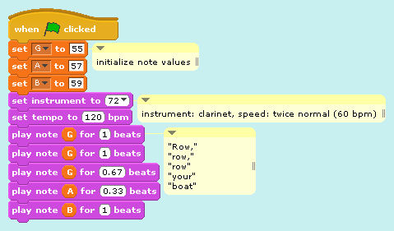

**Progressive Music Examples**

**No. 3: Separating Initialization**

**Two Scripts**

(3a) **Main** Script

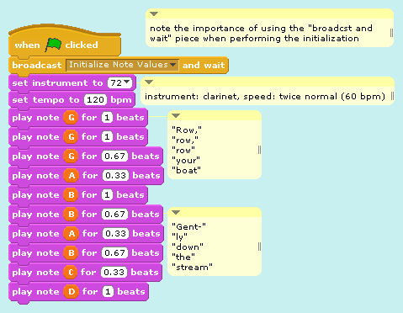

*continued on next page*

**Progressive Music Examples**

**No. 3: Separating Initialization** (cont’d)

(3b) **Initialization (“Init”)** Script

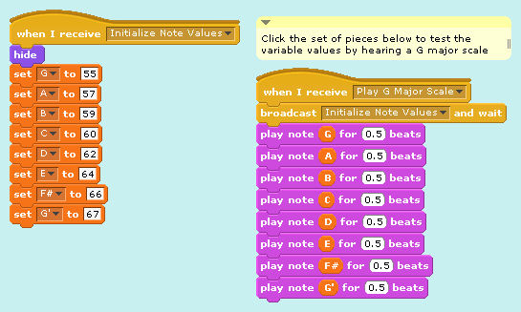

*end of Example 3*

**Progressive Music Examples**

**No. 4: Separating Phrases**

**Three Scripts**

(4a) **Main** Script

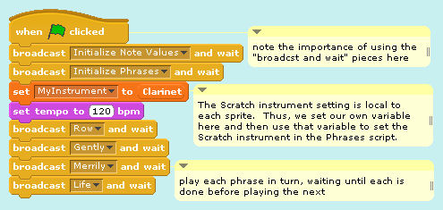

*continued on next page*

**Progressive Music Examples**

**No. 4: Separating Phrases** (cont’d)

(4b) **Initialization (“Init”)** Script

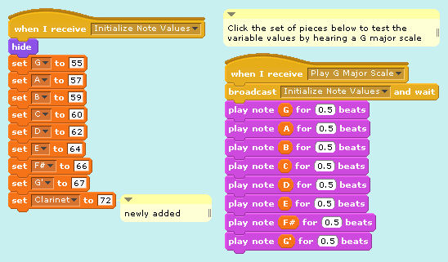

*continued on next page*

**Progressive Music Examples**

**No. 4: Separating Phrases** (cont’d)

(4c) **Phrases** Script

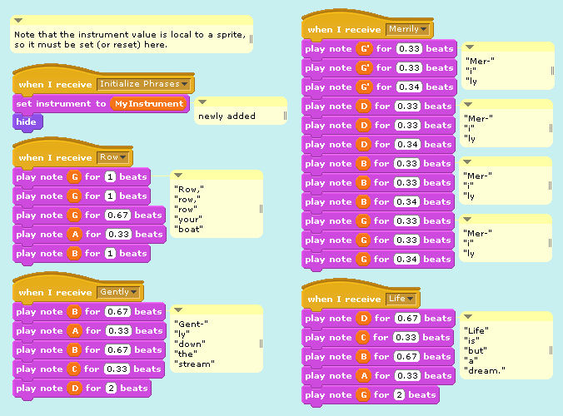

*end of Example 4*

**Progressive Music Examples**

**No. 5: Looping and Fading**

**Three Scripts**

(5a) **Main** Script

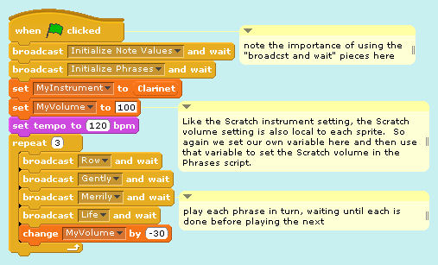

(5b) **Initialization (“Init”)** Script

(*same as on page 12*)

*continued on next page*

**Progressive Music Examples**

**No. 5: Looping and Fading** (cont’d)

(5c) **Phrases** Script

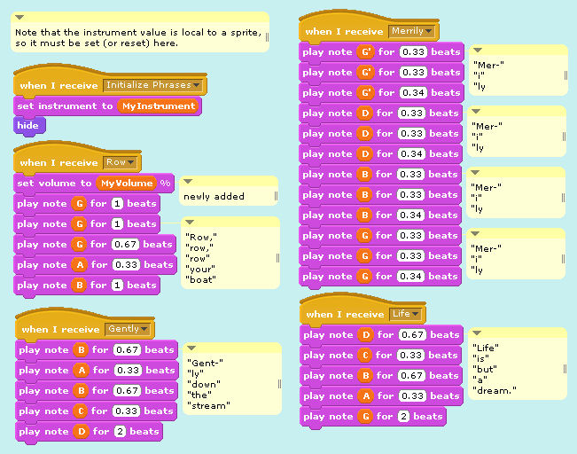

*end of Example 5*

**Progressive Music Examples**

**No. 6: Playing a Round with   
One Instrument**

**Three Scripts**

(6a) **Main** Script

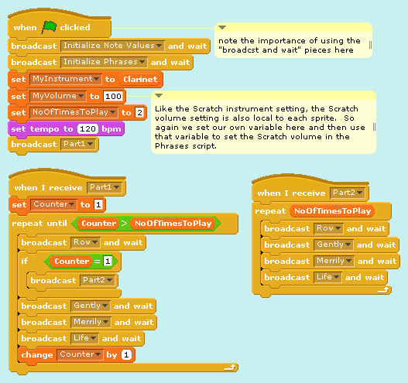

**Progressive Music Examples**

**No. 6: Playing a Round with   
One Instrument** (cont’d)

(6b) **Initialization (“Init”)** Script



(6c) **Phrases** Script

(*same as on page 16*)

*end of Example 6*

**Progressive Music Examples**

**No. 7: Playing a Round with   
Two Instruments**

**Five Scripts**

(7a) **Main** Script

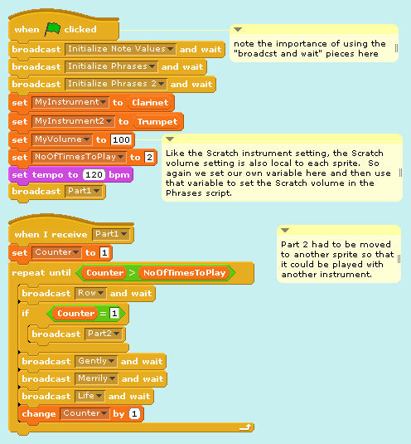

**Progressive Music Examples**

**No. 7: Playing a Round with   
Two Instruments** (cont’d)

(7b) **Initialization (“Init”)** Script

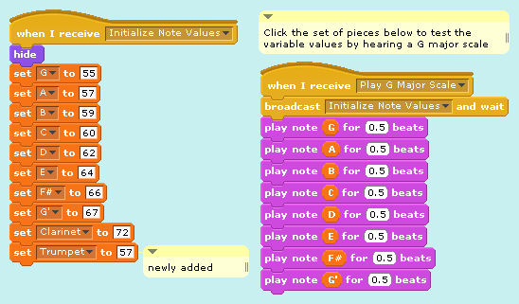

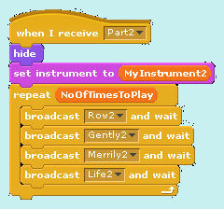(7c) **Phrases** Script

(*same as on page 16*)

(7d) **Part2** Script

*continued on next page*

**Progressive Music Examples**

**No. 7: Playing a Round with   
Two Instruments** (cont’d)

(7e) **Instrument2 (“Instru2”)** Script

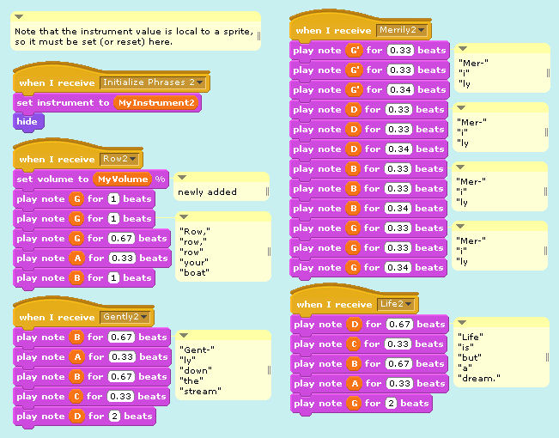

*end of Example 7*

**Progressive Music Examples**

**No. 8: Storing Notes and Rhythms   
in Lists**

**Output Window**

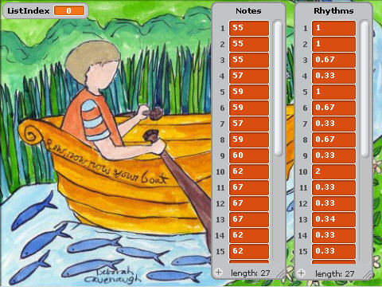

*continued on next page*

**Progressive Music Examples**

**No. 8: Storing Notes and Rhythms   
in Lists** (cont’d)

**Single Script**

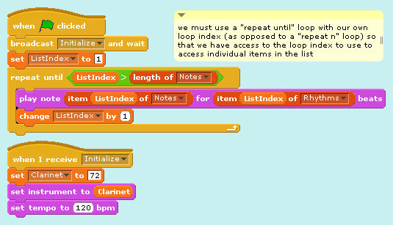

*end of Example 8*

**Progressive Music Examples**

**No. 9: Playing a Round Using Lists**

**Three Scripts**

(9a) **Main** Script

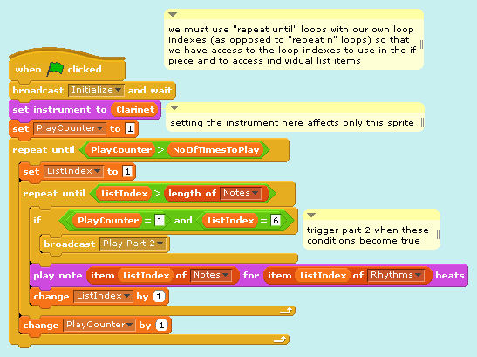

*continued on next page*

**Progressive Music Examples**

**No. 9: Playing a Round Using Lists** (cont’d)

(9b) **Initialization (“Init”)** Script

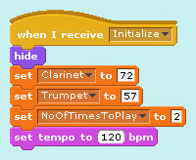

(9c) **Part2** Script

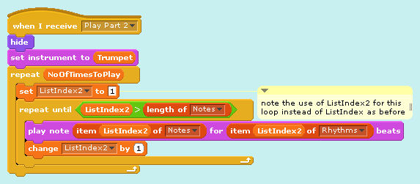

*end of Example 9*

**Progressive Music Examples**

**No. 10: Synchronizing Play from Lists**

**Four Scripts**

(10a) **Main** Script

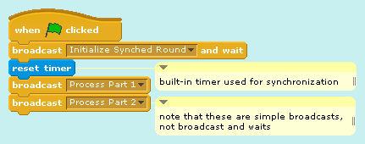

(10b) **Initialization (“Init”)** Script

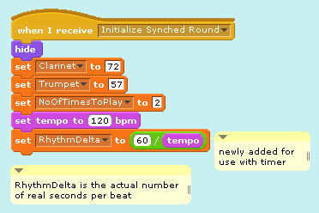*continued on next page*

**Progressive Music Examples**

**No. 10: Synchronizing Play from Lists** (cont’d)

(10c) **Part 1** Script

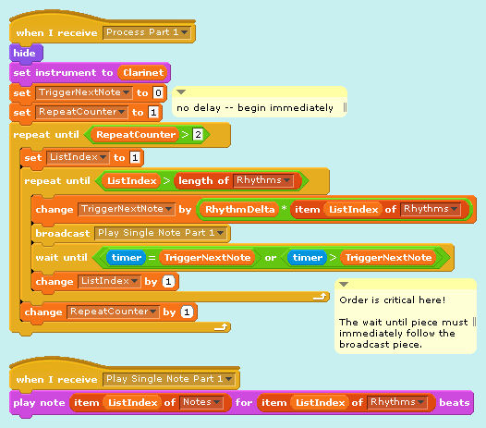

*continued on next page*

**Progressive Music Examples**

**No. 10: Synchronizing Play from Lists** (cont’d)

(10d) **Part 2** Script

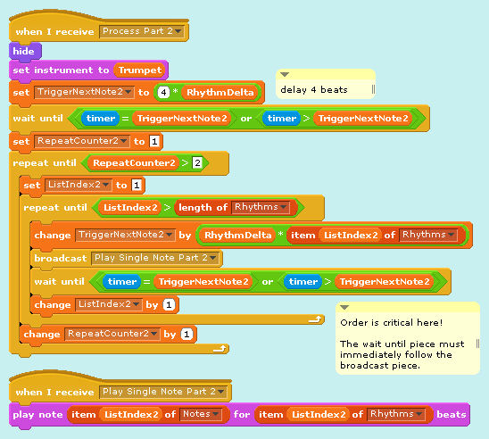

*end of Example 10*

**Progressive Music Examples**

**Ideas for Extending the Examples**

1. **Use a variable to set the tempo.**
   * Add a slider to the variable so that you can change the tempo in real time.
   * Find all the places you need to use the variable to reset the tempo when you change it in real time.
   * Which version of playing the round best stays synchronized when you change the tempo?
2. **Transpose the melody to another key.**
   * Create a variable to hold a pitch offset.
   * Find all the places you need to use that variable to play the melody in the new key.

**Progressive Music Examples**

**Ideas for Extending the Examples** (cont’d)

1. **Increase the number of times that the round repeats.**
   * Do the parts stay in synch?
2. **Increase the number of parts that play simultaneously.** (Be sure to set Turbo Speed before you try this!)
   * When should each part “come in”?
   * How much should the first beat of each part be offset?
3. **Play the melody backwards.**
   * Can you play multiple parts backwards, too?

**Progressive Music Examples**

**Ideas for Extending the Examples** (cont’d)

1. **Make a round using the G-major scale.**
   * Put the note values for a G-major scale into a list. See page 10 for code that initializes and plays a G-major scale, but remember that you must use the integer values, not the variable names, to play notes from a list.
   * Start Part 2 when Part 1 plays its third note (B, MIDI note #59).
   * Add Part 3, starting when Part 1 plays its fifth not (D, #62).

**Progressive Music Examples**

**Ideas for Extending the Examples** (cont’d)

1. **Play random notes in the G-major scale.** 
   * Start with the list created for the previous exercise.
   * Use the “pick random” piece in the Operators group to pick a random note from the list.
   * Play each note for 0.25, 0.50, 0.75, or 1.00 beats, also selected randomly.
   * Does the result sound musical?

**Progressive Music Examples**

**Ideas for Extending the Examples** (cont’d)

1. **Create a program that can play any major scale given any starting note.** 
   * Store the starting note in a variable.
   * For a major scale, the number of half-tones between each note is:

2, 2, 1, 2, 2, 2, 1

* + Another way to think about this is:

Do + 2 Re + 2 Mi + 1 Fa + 2   
Sol + 2 La + 2 Ti + 1 Do

* + Create a list containing the changes between the notes, and then use a loop to process the list and play the scale.

**Progressive Music Examples**

**Ideas for Extending the Examples** (cont’d)

1. **Create a program that can play any harmonic minor scale given any starting note.** 
   * For a harmonic minor scale, the number of half-tones between each note is:

2, 1, 2, 2, 1, 3, 1

* + Create a new list containing these changes, but use the same loop that you created for the previous exercise to play this scale.

**Progressive Music Examples**

**Ideas for Extending the Examples** (cont’d)

1. **Create a program to play a major chord.** 
   * A major chord is the 1st, 3rd, and 5th notes of the scale, usually complemented by the octave above the 1st note. Thus, a G-major scale has notes G (#55), B (#59), D (#62), and G’ (#67).
   * Another way to think about this is to compute the half-tone difference from the starting note: 0, 4, 7, 12.
   * Set a starting note and then use a “broadcast” to play the four notes simultaneously.