

GUI II PROJECT PROPOSAL
Prepared By: Rajia Abdelaziz, Jeremy Daigneau, Madhumathi Prakash and Alex Chen

TABLE OF CONTENTS

Goal Statement………………………………………………….3

Feature Descriptions…………………………………………....3

Component Details……………………………………………...8

User Descriptions………………………………………………..9

Discussion of Issues…………………………………………….9

Schedule………………………………………………………..10

Accessibility Criteria…………………………………………...12

Goal Statement

Flaire by invisaWear technologies offers individuals the ability to contact emergency services with the touch of a button. invisiWearTechnologies.com is a website that allows customers to learn about the product, view product inventory, "purchase" a product, and create an account on the website to configure their device's settings.

Feature Descriptions

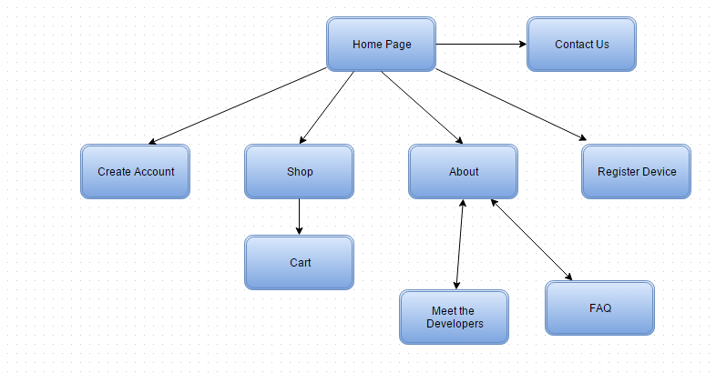

The end product will implement the following pages:

The Home Page

The home screen will display the company and the product name as well as the logo. There will be slides that show sample product images. It will also provide links for users to create a new account or log into their account if they already have one. It will also have a tab called About, which will have information about the product, FAQ, and information about the developers. There will be be a shop tab, which will contain options to purchase a device, jewelry, or a combination pack with a device already embedded within the jewelry. Lastly, there will be a tab called Register Device. This will allow the user to register their newly purchased device. At the bottom of the home page, there will be information regarding how to contact the developers and will provide their emails and phone numbers. All the tabs will be in a menu bar on top and to make it more user friendly, it will still be visible as users scroll up or down.

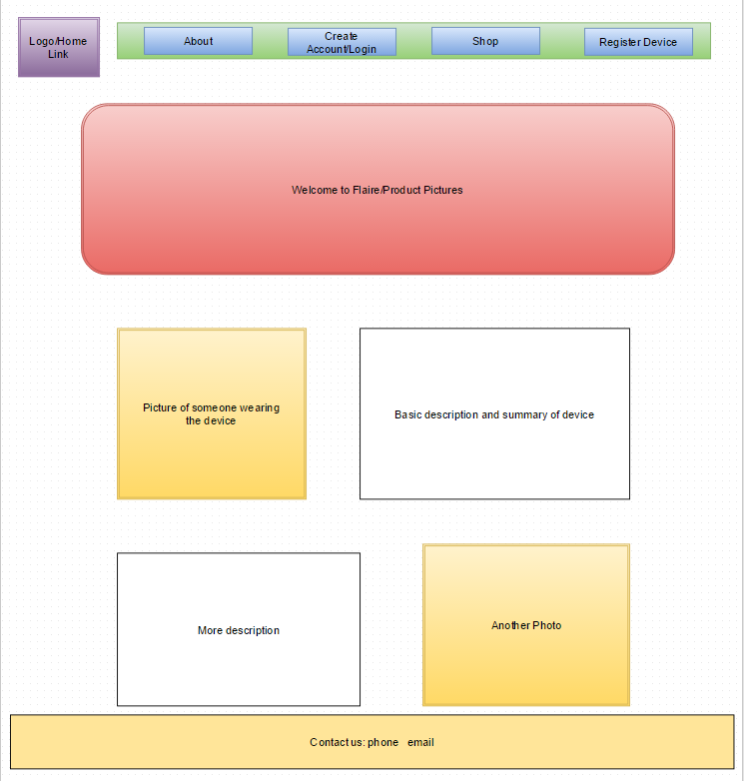

About

The about page will contain information about the product. There will be links that will take the user to a FAQ’s Page, About the Developers page and a page on how to setup their device. The about developers tab will have sections with pictures of the developers and a brief description about them. There will be a link to take the user back to the about page. The link for the how to setup the devices will take you to a different page and it will have different sections. One section will have information about how to put the device into the jewelry. Another section will explain how to setup the android application and device. The FAQ link will have questions about the different links on the side and the details about them.
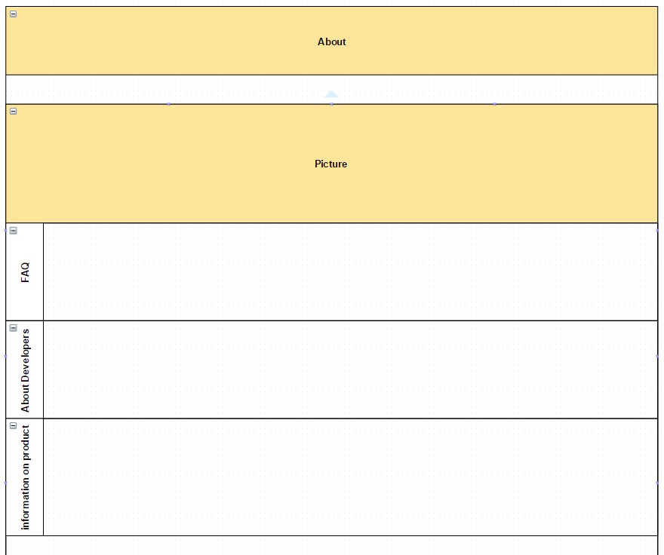

FAQ:
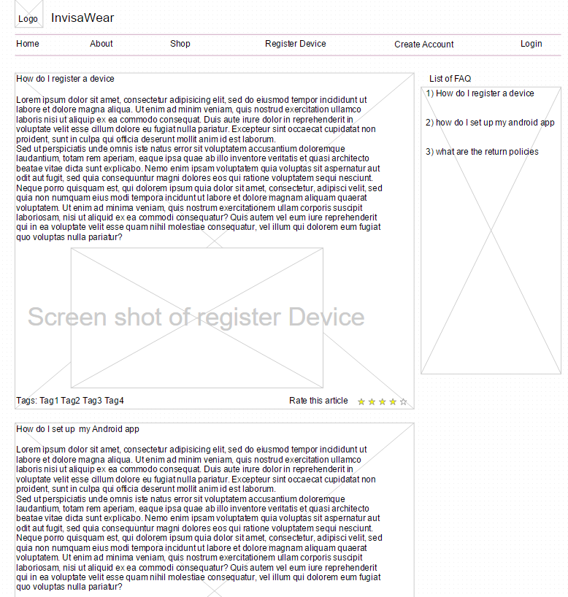
Shop

The shop tab from the home page will be divided into three sections. Each section will have an option to scroll through products with scroll buttons on the left and right. Each product will have its price listed below it. When the user clicks on the product, they will be taken to another page. On this page it will have the product zoomed in. The user can also choose the size with the drop down and the color. There will also be an option to add to cart. On the top right of each page there will be a cart symbol that can be clicked. This will take the user to proceed to checkout page.
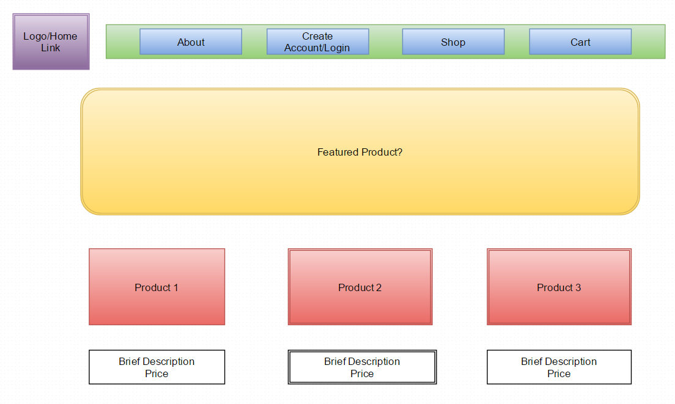

Proceed to check-out

On this page user will have the listing of all the products in their cart. At the bottom they can click on next which will allow them to enter their credit card information and their address and click on the order button. Lastly it will say “thank you for purchasing an invisaWear product”.
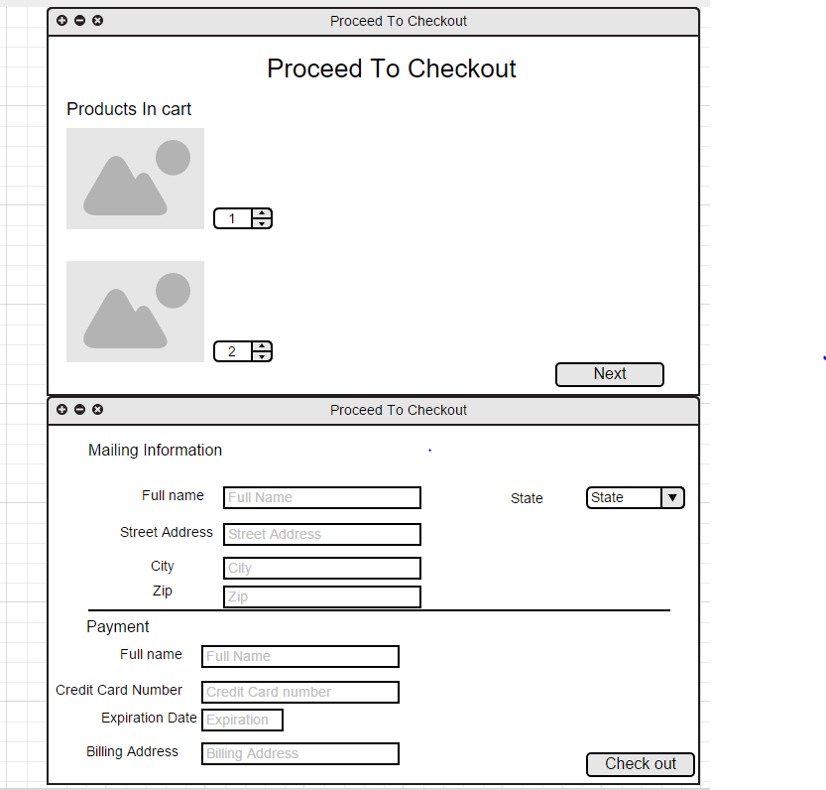

Create an account/Login

The user can get to this page from the link on the home page. It will be divided into two parts. The left side will be the login page for users who already have an account and the right side will be a create account option. The create account will be a form where user the user can fill out their name, email, username, and password. After completing all the required information on the form, the user will be taken back to the home page. On the login page the user can input their username and password into a textbox and submit. If the information is valid, they will be redirected to the home page and their username will show up on the top right.
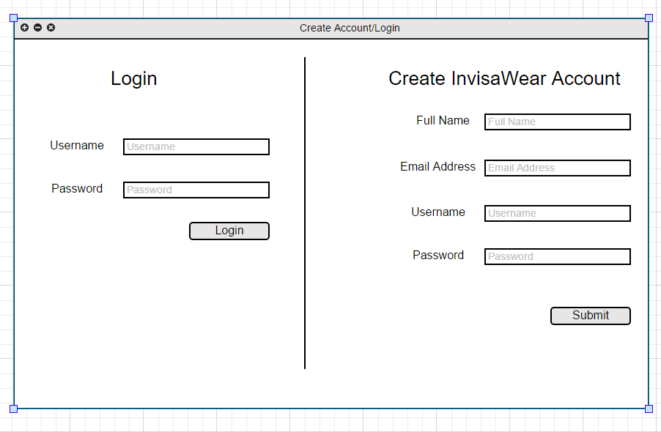
Component Details

Working on this :)

User Descriptions
According to the Institute of Education Sciences, approximately 20.2 million people in the U.S attend colleges and universities. Statistics from the FBI show that over the past year more than 10 thousand crimes occurred on college-campuses. This leaves students feeling unsafe and defenseless in the event of an emergency and makes them the perfect market to purchase a wearable safety device.
For years, companies have targeted college students because they’re part of a very desirable demographic since they have yet to form unbreakable brand loyalties. If the founders of invisaWear Technologies can connect with college students, the business will have a chance to grow with them as they graduate, start careers and begin families of their own. This will allow them to develop brand loyalty and expand our market as time progresses. In the future, the device can be sold to companies where people tend to stay late at the office and feel uncomfortable as they’re leaving, or at elementary/middle schools to parents who would like to ensure their child is safe walking home from school. Thus in the meantime, the main customers of the site will be college students (both females and males). However, in the future, the market will expand to adults and children.

Discussion of Issues
As with any project, various issues are bound to cause roadblocks for development, many of which will not be anticipated. However, there are some situations that the developers of the website anticipate running into.
The first issue is consistent among any project, time. Time will limit how much of the website will be able to be completed, how polished and styled it can be, and how many features can be added by the time the first version is to be released. On top of development deadlines, all members involved in the project are students with full course loads, leading to very busy lives, further limiting the time available for the project. In preparation for this factor, a plan will be made to help reasonably allocate the time available and to use it in a very efficient way.
The next issue is really a collection of possible problems that can be summarized as technical difficulties. The website will incorporate various different types of programming languages that will be used in even more various ways. Many of these techniques will have to be learned for the first time or be refreshed, before being implemented. Specific examples include jQuery validation for account registration, Javascript to allow for pictures slide shows of the product our website is promoting, Javascript to allow for website responsiveness on mobile devices, and possibly other jQuery and Javascript libraries that will cause the website to look polished, feel responsive, and be functional.
The third issue is due to the product the website is promoting. The website’s purpose is to showcase the Flaire product. As a result, the website must accurately display and advertise the product as best as possible. Therefore, if Flaire undergoes any changes, the website must be updated to show this. Any unexpected product change will result in unexpected updates to the website. This, along with time restraints, could cause the website to show inaccurate information if the website cannot be updated promptly. In addition, any new versions of the product would also need to be displayed on the website. This means the website will have to be constantly updated and developed alongside of the product to maintain information integrity.

Schedule

Goal | Date | Assignee
1. Proposal | 2/4 | Everyone
2. Set up GIT repository | 2/6 | Everyone
3. Set up environment | 2/7 | Everyone
4. Create navigation bar | 2/8 | Jeremy
5. Create a theme and color scheme for all the webpages to follow | 2/12 | Everyone
6. Take Pictures of the Products and Pictures for the Website | 2/14 | Rajia and Madhu
7. Setup Skeleton of Pages  - Create all pages without styling  - Visual Mock-Ups of all pages | 3/1 | Everyone
7.1 Setup skeleton of  Home Page | 2/24 | Rajia
7.2 Setup skeleton of  About page | 3/1 | Rajia
7.3 Setup skeleton of  FAQ page | 2/21 | Madhu
7.4 Setup skeleton of  About the Developers page | 2/25 | Madhu
7.5 Setup skeleton of  Setting Up Device | 3/1 | Madhu
7.6 Setup skeleton of  Shop | 2/24 | Jeremy
7.7 Setup skeleton of  Product Details Page | 3/1 | Jeremy
7.8 Setup skeleton of  Create Account/Login | 2/19 | Alex
7.9 Set up skeleton of  Register Device | 2/22 | Alex
7.10 Set up skeleton of proceed to checkout | 3/1 | Alex
8. Implement navigation between pages and links | 3/5 | Everyone
Implement javascript validations on all forms | 3/12 | Rajia and Madhu
Styling validation | 3/12 | Alex
Implement picture slide for all pages that require it | 3/19 | Rajia
Dynamically change picture and price on product details page |  | Jeremy
Implement Checkout/ Store Items in Shopping Cart | 3/26 | Alex
Implement Function to Calculate Shopping Totals | 4/2 | Madhu
Hard code user login | 4/9 | Madhu
Usability testing | 4/14 | Everyone
Final Enhancements/Product updates | 4/20 | Everyone
Final Presentations | 4/24 | Everyone

Acceptability Criteria

Minimum Functionality for Release

- Customers will be able to:
  - Understand what the product is (home page, about page) by reading descriptions and viewing pictures/diagrams on the home page that illustrate products

  - Login/Sign up for user accounts. There they will be able to change their user and product settings.

  - Register their products using unique product IDs and input personal information that will be helpful in case of emergency (i.e name, gender, age, height, etc)

  - View inventory, which is separated into sections based on what product types/combinations they want (i.e bracelet by itself)

  - Add products to the shopping cart

  - Have their questions answered on a FAQ page

  - Contact the developers by finding contact information

- Website will have:
  - An appealing color scheme that’s not too “aggressive”. Light greenish?

  - Links to most other pages on the home page for easy navigation. This is so customers can have easy access to the other important pages all from one single page

  - Detailed about, contact, FAQ pages for customer convenience

  - Detailed descriptions about the products and accompanying pictures on the home page and the shop page

  - The shop page will have an easy to use navigation system and products will be intuitively placed with short descriptions and accompanying pictures.

- Nice-to-have features that will be implemented if there’s time
  - More advanced CSS/design?

- Features that will most likely not be implemented but that might influence the design
  - Login/signup/registration will be hardcoded but will still influence the design of the related pages (login text boxes to type in, etc)

https://teaching.cs.uml.edu/~heines/91.462/91.462-2014-15s/462-assn/SampleProjectProposals-2014/Carcia-Soeltz_graded.pdf

https://www.draw.io

http://salesmanagement.org/web/uploads/pdf/af4610022ea794e97eee259432519a92.pdf

Mock up of site flow
https://www.draw.io/#G0Bw9jjlWfrm9lZUdWYlc0SV9HOE0

Presentation

Criteria | Possible  Points
Goal Statement  - clear, concise, realistic | 4
Feature Descriptions  - practical, doable  - comply with GUI standards  - clearly described | 8
Component Details  - researched, not just assumed  - locations and references cited | 6
User Descriptions  - specific and focused | 4
Discussion of Issues  - realistic  - alternatives and/or fallback strategies proposed | 4
Schedule  - good selection of milestones  - realistic expectations | 4
Acceptability Criteria  - clear enough to be applied by someone other than yourself  - germane to the project goal | 4
Presentation  - professional look  - logical organization and structure  - correct spelling and grammar | 6

page settings
- title page- title of the project, team members, date, version number
- headers and footers
  - numbering pages- go to fields in view
- automatic generation of tables of contents-enter Table of contents and then select in fields TOC
using styles- for the header of each section select Heading 1/Heading 2
For headers under the main section header select normal
paragraph settings- modify the normal style to times in new roman 12pt
- lines per inch
- indentation
- space after
- Justification- left justification
- borders and shading-make things pop out
- widow line control
  - “keep line with next”
  - widow heads
using lists
- bulleted
- numbered
- outline numbered
proper use of fonts
- point size
proper use of spaces and tabs
- types of tabs
- dots and lines…double click on the ruler to add
- adjusting default settings
inserting and manipulating graphics
- working with screen captures
- labeling tables and figures
inserting and numbering code
citing references

From <https://teaching.cs.uml.edu/~heines/91.462/91.462-2015-16s/462-lecs/lecture04.jsp>

